PIZZA SALES SQL QUERIES

1. KPI’s

1)Total Revenue:

SELECT SUM(total_price) AS Total_Revenue

FROM pizza_sales

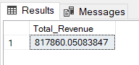

2)Average order value:

SELECT SUM(total_price) / COUNT(DISTINCT order_id) AS Avg_Order_value

FROM pizza_sales

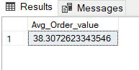

3)Total Pizza Sold:

SELECT SUM(quantity) AS Total_Pizza_Sold

FROM pizza_sales

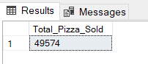

4)Total Orders:

SELECT COUNT(DISTINCT order_id) AS Total_Orders

FROM pizza_sales

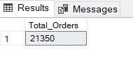

5)Average Pizzas per Order:

SELECT CAST( CAST(SUM(quantity) AS DECIMAL(12,2)) / CAST(COUNT (DISTINCT order_id) AS DECIMAL (10,2)) AS DECIMAL (10,2)) AS Avg_Pizza_Per_Orders

FROM pizza_sales

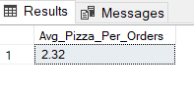

1. Daily Trend for Total Orders:

SELECT DATENAME( DW, order_date) AS Order_Day, COUNT(DISTINCT order_id) AS Total_Orders

FROM pizza_sales

GROUP BY DATENAME( DW, order_date)

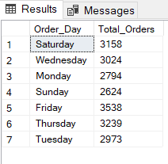

1. Monthly Trend for Total Orders:

SELECT DATENAME( MONTH, order_date) AS Order_Month, COUNT(DISTINCT order_id) AS Total_Orders

FROM pizza_sales

GROUP BY DATENAME( MONTH, order_date)

ORDER BY Total_Orders desc

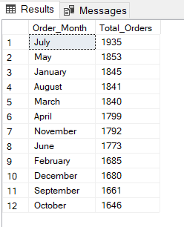

1. % of Sales by Pizza Category:

SELECT pizza_category,CAST( SUM(total_price) AS DECIMAL(10,2)) AS Total_Sales,

CAST(SUM(total_price) * 100 / (SELECT SUM(total_price) FROM pizza_sales) AS DECIMAL (10,2)) as PCT

FROM pizza_sales GROUP BY pizza_category

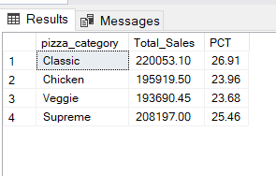

1. % of Sales by Pizza Size:

SELECT pizza_size,CAST( SUM(total_price) AS DECIMAL(10,2)) AS Total_Sales,

CAST(SUM(total_price) * 100 / (SELECT SUM(total_price) FROM pizza_sales) AS DECIMAL (10,2)) AS PCT

FROM pizza_sales

GROUP BY pizza_size

ORDER BY PCT DESC

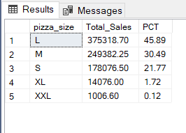

1. Total Pizzas Sold by Pizza Category:

SELECT pizza_category, SUM( quantity) AS Total_Quantity_Sold

FROM pizza_sales

GROUP BY pizza_category

ORDER BY Total_Quantity_Sold DESC

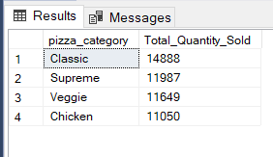

1. Top 5 Best Sellers by Revenue :

SELECT TOP 5 pizza_name,SUM(total_price) AS Total_Revenue

FROM pizza_sales

GROUP BY pizza_name

ORDER BY Total_Revenue DESC

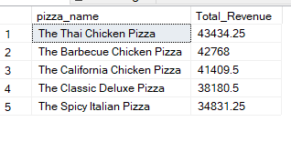

1. Bottom 5 Sellers by Revenue:

SELECT TOP 5 pizza_name,SUM(total_price) AS Total_Revenue

FROM pizza_sales

GROUP BY pizza_name

ORDER BY Total_Revenue ASC

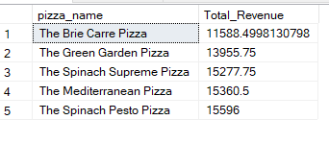

1. Top 5 Sellers by Quantity:

SELECT TOP 5 pizza_name,SUM(quantity) AS Total_Pizza_Sold

FROM pizza_sales

GROUP BY pizza_name

ORDER BY Total_Pizza_Sold DESC

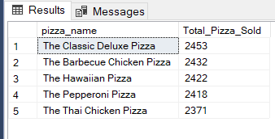

1. Bottom 5 Sellers by Quantity :

SELECT TOP 5 pizza_name,SUM(quantity) AS Total_Pizza_Sold

FROM pizza_sales

GROUP BY pizza_name

ORDER BY Total_Pizza_Sold ASC

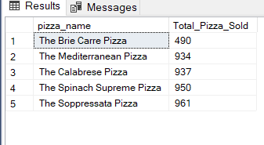

1. Top 5 Sellers by Total Orders:

SELECT TOP 5 pizza_name,COUNT(DISTINCT order_id) AS Total_Orders

FROM pizza_sales

GROUP BY pizza_name

ORDER BY Total_Orders DESC

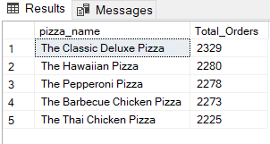

1. Bottom 5 Sellers by Total Orders:

SELECT TOP 5 pizza_name,COUNT(DISTINCT order_id) AS Total_Orders

FROM pizza_sales

GROUP BY pizza_name

ORDER BY Total_Orders ASC

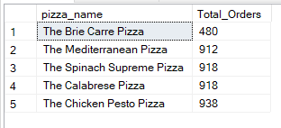

NOTE:

If you want to apply the pizza_category or pizza_size filters to the above queries, you can use a WHERE clause. Follow some of the examples below

SELECT TOP 5 pizza_name, COUNT(DISTINCT order_id) AS Total_Orders

FROM pizza_sales

WHERE pizza_category = 'Classic'

GROUP BY pizza_name

ORDER BY Total_Orders ASC

Which gives you the output below:

